- This week's UK inflation release and flash S&P Global survey are unlikely to have moved the dial on the monetary policy debate. We continue to think there's several more rate cuts to come over the next 18 months, but the timing of those moves is very uncertain.
- The problems engulfing the Office for National Statistics deepened with the postponement of July's retail sales release. Delayed releases, large revisions, and more volatile series are increasingly undermining the Monetary Policy Committee's ability to monitor the economy.
In the minutes of its August meeting, the Bank of England's Monetary Policy Committee sent a clear message that the strength of current inflationary pressures was again its priority, expressing concerns about the potential impact on inflation expectations from high readings for headline inflation and the highly salient food and fuel categories.
In the first inflation release since that meeting, the CPI measure rose to 3.8% in July from 3.6% in June, slightly above both our expectation and the consensus forecast. Part of the month's increase reflected a smaller drag from the fuel category. But the main source of July's upside surprise was movements in the notoriously volatile air fares and accommodation services sub-categories.
Strikingly, air fares rose 30.2% m/m, which was the largest July increase since monthly data collection for air fares began in 2001. The Office for National Statistics linked the unusually strong outturn to a later price collection date, which coincided with the timing of school summer holidays. Meanwhile, upward pressure from the accommodation services category was primarily due to higher hotel prices. Together, these two services sub-categories alone added 0.2ppts to headline inflation.
However, these movements should unwind again in the next couple of months. And we calculate that the MPC's favoured measure of underlying price pressures, which strips out indexed and volatile components, rent, and foreign holidays from services inflation, edged downwards in July (Chart 1).
Chart 1: Inflation rose, but the BoE's preferred measure of underlying pressures cooled slightly in July
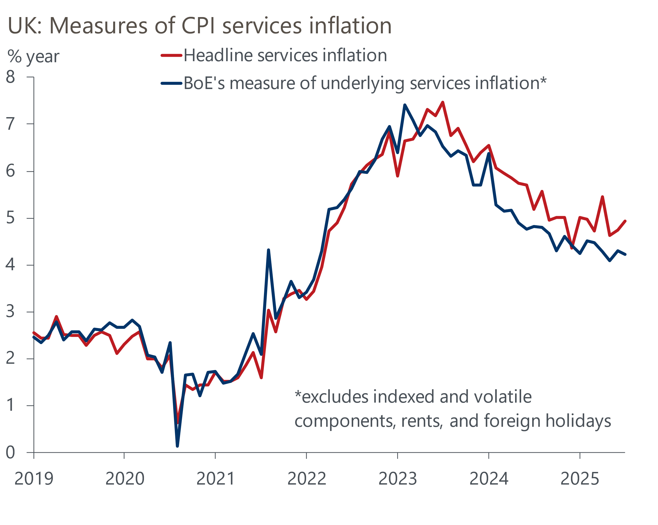
Source: Oxford Economics calculations using data from Haver Analytics

Our takeaway from the release was that there was little in the way of genuine news that shifted the monetary policy debate in either a more hawkish or dovish direction. We drew similar conclusions from the week's other main data release, August's flash S&P Global survey.
August's survey reported a surprisingly large improvement in the composite PMI, with the index rising to 53.0, from 51.5 in July. This implied the fastest pace of private sector activity growth in a year. The survey also reported sharply rising input price pressures being passed through to customers, particularly in the services sector. The committee's hawks will likely see signals of solid economic momentum and stronger growth in costs and prices as vindication of their vote to keep Bank Rate unchanged in August.
However, the relationship between the survey and official output data has been particularly poor recently (Chart 2). We suspect the pickup in August's composite PMI was largely sentiment-driven in response to news that the US had agreed a range of trade deals at the start of the month. The true underlying momentum in the economy is likely to be weaker. Moreover, the survey also reported that businesses continue to reduce headcount, which will likely play on the concerns of those MPC members who are particularly worried about the fragility of the labour market and the downward pressure that this could exert on inflation in the medium term.
Chart 2: The composite PMI has been a relatively poor leading indicator of GDP growth in recent years
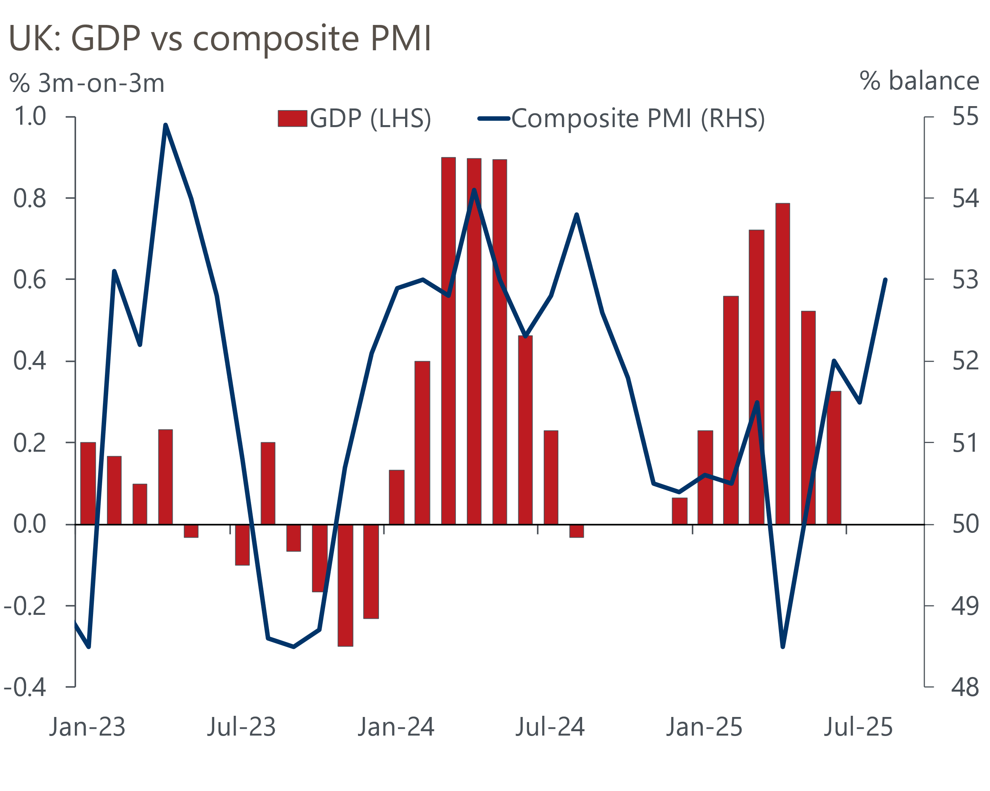
Sources: ONS, S&P Global
One factor that is adding to the fog over the monetary policy outlook is that problems with official data are becoming increasingly widespread. The issues with the Labour Force Survey are well known and there's been problems with several other releases this year. The latest setback was the postponement of this week's release of July's retail sales data until September 5 to "allow for further quality assurance". With the ONS being so vague, we can only speculate on what may have caused such a decision. But we have previously flagged our concerns around the ONS' ability to appropriately adjust the raw sectoral retail data in light of changes to the seasonal pattern of sales. We suspect this has contributed to the very large swings we have seen in recent retail outturns.
Postponed releases, large revisions, and more volatile data are increasingly undermining the BoE's ability to monitor conditions in the economy and set monetary policy accordingly. Looking through all the noise, we don't think this week's data have shifted the monetary policy dial in a meaningful way. We continue to think that several more Bank Rate cuts are likely over the next 18 months. However, there's now considerable uncertainty around the timing of those moves, and a scenario in which the MPC slowly feels its way to a neutral level over a long time horizon is becoming more compelling.

The week ahead
There are no major releases next week.

Key forecasts
Table 1: UK forecast overview
(Annual percentage changes unless specified)
 | 2023 | 2024 | 2025 | 2026 | 2027 | 2028
GDP | 0.4 | 1.1 | 1.3 | 0.9 | 1.3 | 1.7
Private consumption | 0.5 | 0.6 | 1.0 | 1.0 | 1.2 | 1.7
Fixed investment | 0.3 | 1.5 | 1.9 | 1.0 | 1.6 | 2.0
Government consumption | 1.6 | 3.0 | 1.8 | 1.8 | 1.6 | 1.7
Exports of goods and services | -0.4 | -1.2 | 2.2 | 0.2 | 1.2 | 1.4
Imports of goods and services | -1.2 | 2.7 | 3.9 | -0.9 | 1.1 | 1.4
Industrial Production | -0.8 | -1.2 | 0.3 | -0.4 | 0.8 | 1.2
Consumer prices | 7.3 | 2.5 | 3.4 | 2.7 | 2.4 | 2.1
Unemployment rate (%) | 4.1 | 4.3 | 4.7 | 4.9 | 4.8 | 4.4
Current a/c balance (% of GDP) | -3.5 | -2.7 | -3.3 | -3.1 | -2.9 | -2.8
Government balance (% of GDP) | 5.2 | 5.2 | 4.4 | 3.5 | 2.9 | 2.6
Central bank policy rate (%, EOP) | 5.25 | 4.75 | 3.75 | 3.00 | 2.50 | 2.50
10yr govt. bond yield (%, EOP) | 3.54 | 4.57 | 4.63 | 4.13 | 3.49 | 3.35
Exchange rate (US$ per £, EOP) | 1.27 | 1.25 | 1.33 | 1.34 | 1.34 | 1.34
Exchange rate (euro per £, EOP) | 1.15 | 1.21 | 1.15 | 1.15 | 1.15 | 1.15
Source: Oxford Economics
Table 2: Quarterly forecasts for the UK
 | 2025 |  |  |  | 2026
 | Q1 | Q2 | Q3 | Q4 | Q1 | Q2 | Q3 | Q4
GDP (% year) | 1.3 | 1.2 | 1.2 | 1.3 | 0.8 | 0.7 | 0.9 | 1.0
CPI inflation (% year) | 2.8 | 3.5 | 3.8 | 3.6 | 3.3 | 2.4 | 2.5 | 2.5
Bank Rate (%, EOP) | 4.50 | 4.25 | 4.00 | 3.75 | 3.50 | 3.25 | 3.25 | 3.00
10yr gilt yield (%, EOP) | 4.70 | 4.48 | 4.70 | 4.63 | 4.56 | 4.44 | 4.30 | 4.13
US$ per £ (EOP) | 1.29 | 1.37 | 1.33 | 1.33 | 1.33 | 1.33 | 1.34 | 1.34
Euro per £ (EOP) | 1.20 | 1.17 | 1.15 | 1.15 | 1.15 | 1.15 | 1.15 | 1.15
Source: Oxford Economics

Latest Country Economic Forecast:
August 20, 2025

Recent publications

Data Insights
PMI surprise does not necessarily mean a growth pickup
A tax rising Budget is on the cards
Higher inflation in July shouldn't exacerbate the MPC's worries
Strong June and April's upward revision rescue Q2 for GDP
Jobs market offers MPC little confidence on disinflation

Research Briefings
Tight BoE vote to cut casts doubt on the path for rates
MPC Preview - The case for faster cuts has faded for now
Why interest rate cuts remain a blunt tool
BoE likely to slow QT to avoid adding to gilt market strains
How the sectoral mix of jobs is changing and what it means

Contacts

Oxford Economics' UK team
- Andrew Goodwin - Chief UK Economist - agoodwin@oxfordeconomics.com
- Edward Allenby - UK Economist - eallenby@oxfordeconomics.com

